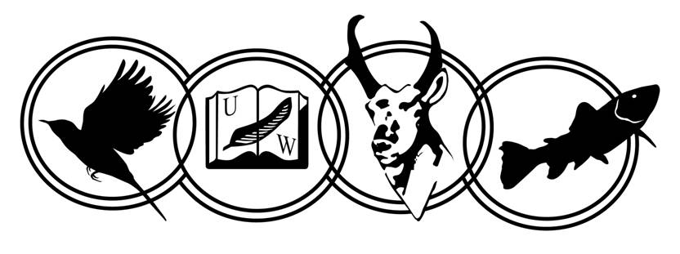
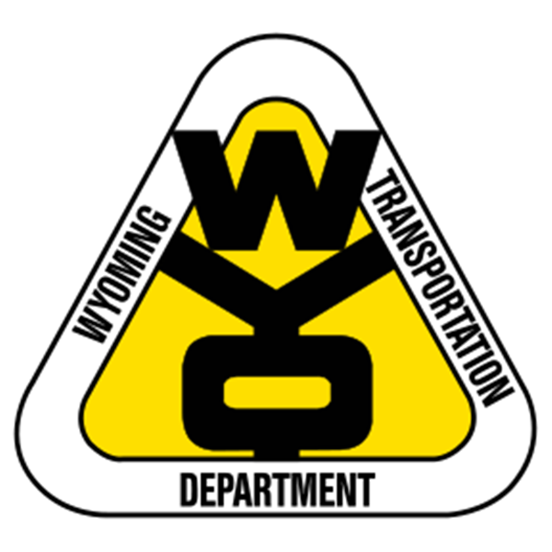
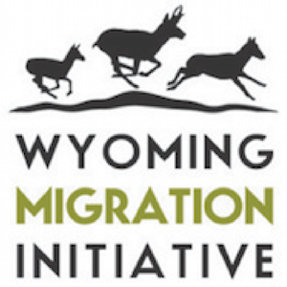
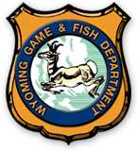

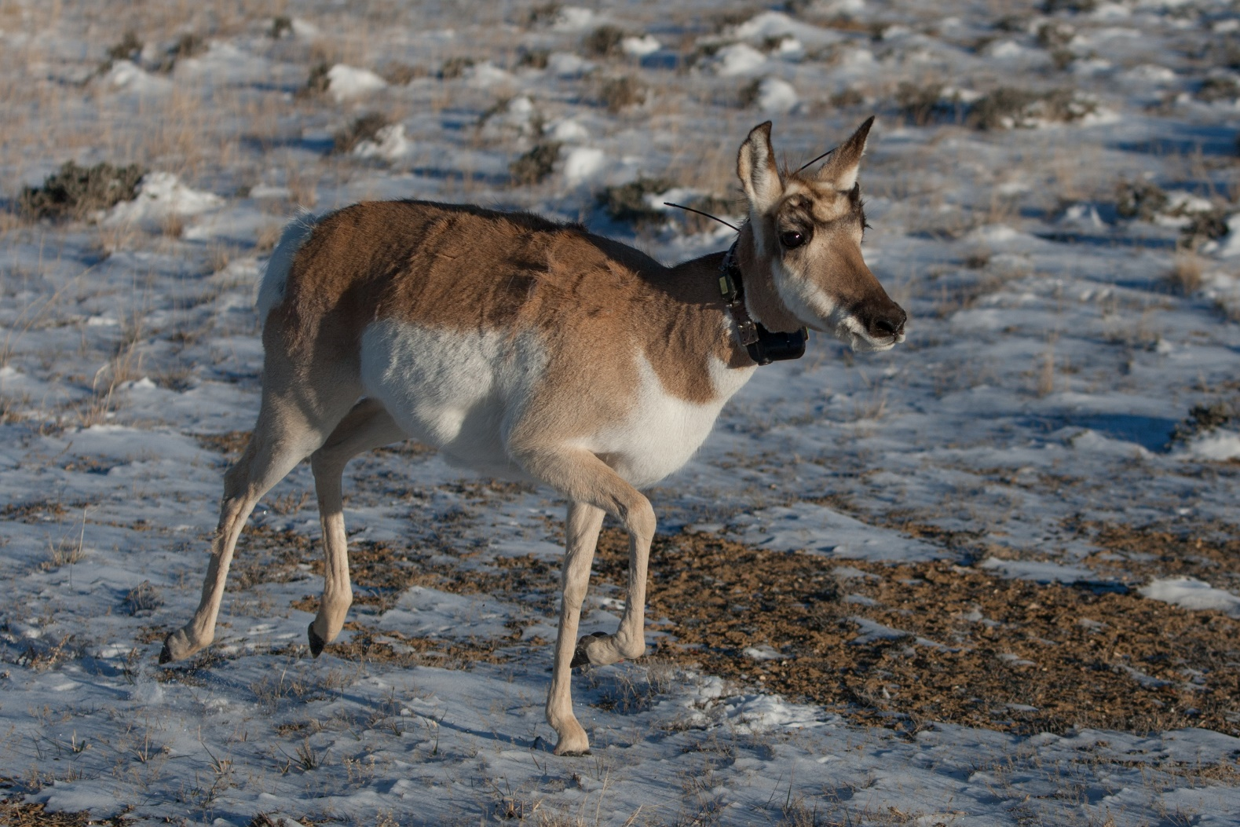
Interstate-80 Corridor: Bitter Creek Road to Highway 189
© Gary Sundberg
2018 Pronghorn Capture Report

Project Background
In March of 2018, we collared 49 female pronghorn (Antilocapra americana) along the Interstate-80 corridor, from the Bitter Creek Road west to Highway 189 at the edge of pronghorn hunt area 94. We have observed that the interstate is a barrier to pronghorn, but how pronghorn interact with the interstate varies substantially by their herd. The aim of this project is to fill in gaps where we still do not have a complete picture of movement behavior of pronghorn herds that winter near the interstate. We plan to learn more of pronghorn movements by covering a more sizable swath of land along the interstate between Evanston and Rawlins. By studying the movement patterns of pronghorn relative to the interstate, we plan to identify potential crossing locations that might restore historical migrations and help facilitate movement. We will then model the movement of pronghorn herds in relation to the interstate to identify the best locations for a crossing structure. Movement analysis and technical work is currently underway by University of Wyoming graduate student Benjamin Robb, under the guidance of Dr. Matthew Kauffman.

Data
This year marks the second year of the study. All individuals in this study are adult females. We allocated pronghorn captures to locations where little or no prior GPS collaring has been conducted. Additionally, we collared in hunt area 94 because of the high density of pronghorn. On March 25th, 2018 we collared 45 pronghorn through helicopter net-gunning by independent contractors. On March 26th, 2018 we collared 4 more pronghorn.
Twenty pronghorn were collared with Lotek Iridium Pro S collars with satellite GPS fixes every two hours and a very high frequency (VHF) beacon transmitting between 9 am and 7 pm (15:00 to 1:00 UTC). These individuals are located north of Interstate-80 near Lyman, in hunt area 94. These collars will be a part of an additional study on aerial infrared surveys of pronghorn. Twenty-five individuals were collared with Telonics Globalstar collars with store-on-board GPS fixes every two hours and a VHF transmission between 9 am and 5 pm (15:00 to 23:00 UTC). We redeployed four Lotek Globalstar Pro S collars with store-on-board GPS fixes every two hours and VHF transmission between 8 am and 6pm. All collars were programmed to drop after 3 years. Real time movement of the pronghorn can be followed through online data providers of Lotek and Telonics.
We collected blood samples from all collared pronghorn, which we provided to the University of Wyoming wildlife veterinary lab to screen for disease and genetic testing. Likewise, we collected fecal samples for nutrition analysis and nasal swabs to screen for pneumonia.

Capture Locations

Map 1- Of the 49 captures, 25 were located North of Interstate-80 near Lyman, WY. Twenty of these captures included the Lotek Iridium collars. Ten captures were south of the Interstate near Lyman, WY to Green River, WY. Five collars were allocated near Green River. Five more collars were allocated near Rock Springs, WY and the last four collars were allocated near Table Rock, WY.

Newly Collared Pronghorn Locations
Map 2 — This map shows movement of the newly collared pronghorn up to April 5th, 2018. The lines designate moved tracks of GPS collared since the day after their collaring.

All Pronghorn Locations
Map 3 — Dataset of all 89 pronghorn collared since March 2017, including the most recent 49 collars.

Acknowledgements
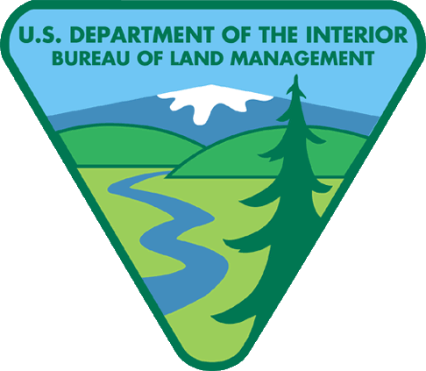
Research partners for this project include Sam Stephens, Jeff Short, Patrick Burke and Mark Zornes at the Wyoming Game and Fish Department and Scott Gamo and Tom Hart at the Wyoming Department of Transportation. This project would not have been possible without the assistance and cooperation provided by landholders including PH Livestock Company, Anadarko Petroleum, Union Pacific Railroad, Uinta Development, Rock Springs Grazing Association, Bureau of Land Management and all other private landholders. We are thankful for the support provided by: Knobloch Family Foundation, Wyoming Department of Transportation and the U.S. Geological Survey.

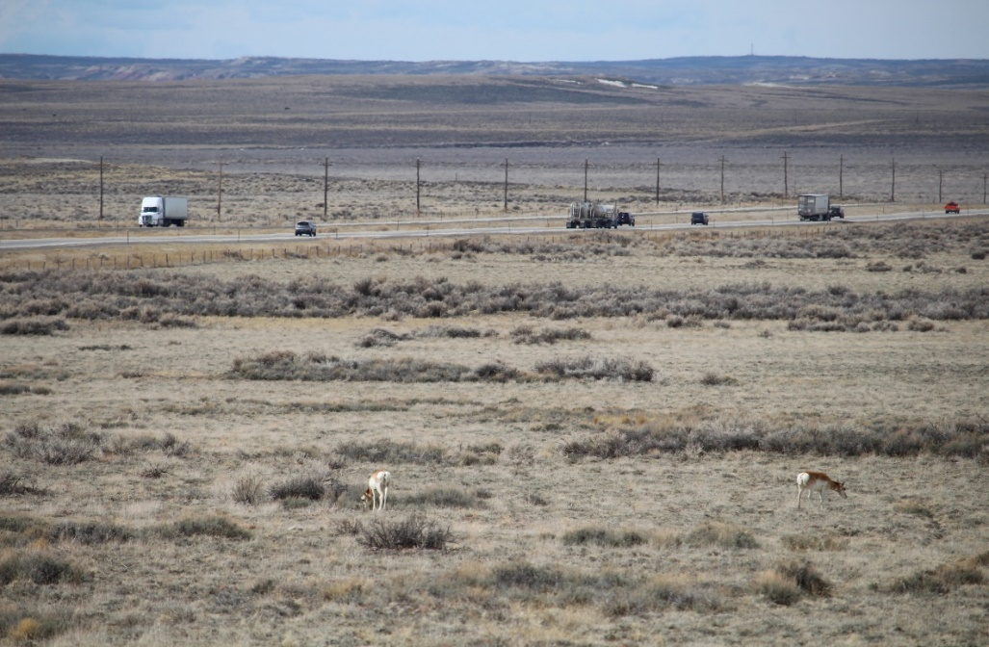
For Further Information Contact
Benjamin Robb – brobb1@uwyo.edu
Bill Rudd – billrudd2@gmail.com
Mark Zornes – Mark.Zornes@wyo.gov
Matthew Kauffman - mkauff1@uwyo.edu

© Gregory Nickerson

